Intro
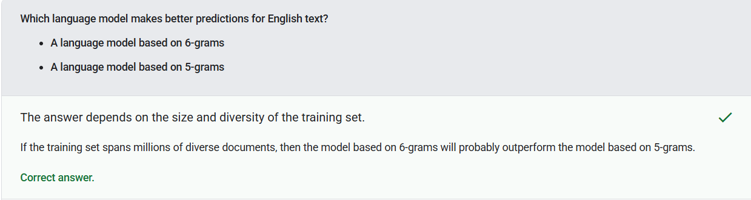
Bigram - An N-gram in which N=2.
Language model - A model that estimates the probability of a token or sequence of tokens occurring in a longer sequence of tokens.
N-gram - An ordered sequence of N words.
Neural network - A model containing at least one hidden layer. A deep neural network is a type of neural network containing more than one hidden layer.
Recurrent neural network - A neural network that is intentionally run multiple times, where parts of each run feed into the next run. Specifically, hidden layers from the previous run provide part of the input to the same hidden layer in the next run.
Token - In a language model, the atomic unit that the model is training on and making predictions on. A token is typically one of the following:
• a word—for example, the phrase "dogs like cats" consists of three word tokens: "dogs", "like", and "cats".
• a character—for example, the phrase "bike fish" consists of nine character tokens. (Note that the blank space counts as one of the tokens.)
• subwords—in which a single word can be a single token or multiple tokens. A subword consists of a root word, a prefix, or a suffix. For example, a language model that uses subwords as tokens might view the word "dogs" as two tokens (the root word "dog" and the plural suffix "s"). That same language model might view the single word "taller" as two subwords (the root word "tall" and the suffix "er").
Trigram - An N-gram in which N=3.
Vanishing gradient problem - The tendency for the gradients of early hidden layers of some deep neural networks to become surprisingly flat (low). Increasingly lower gradients result in increasingly smaller changes to the weights on nodes in a deep neural network, leading to little or no learning.
What's a Large Language Model?
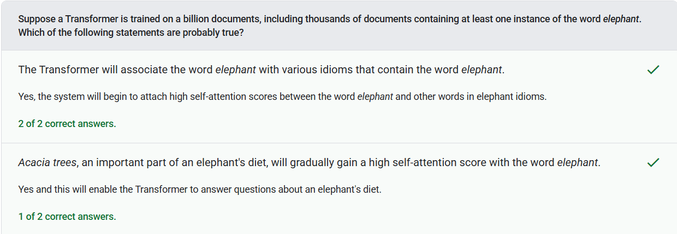
Decoder - In general, any ML system that converts from a processed, dense, or internal representation to a more raw, sparse, or external representation.
Embedding layer - A special hidden layer that trains on a high-dimensional categorical feature to gradually learn a lower dimension embedding vector. An embedding layer enables a neural network to train far more efficiently than training just on the high-dimensional categorical feature.
Encoder - In general, any ML system that converts from a raw, sparse, or external representation into a more processed, denser, or more internal representation.
Hallucination - The production of plausible-seeming but factually incorrect output by a generative AI model that purports to be making an assertion about the real world.
Instruction tuning - A form of fine-tuning that improves a generative AI model's ability to follow instructions. Instruction tuning involves training a model on a series of instruction prompts, typically covering a wide variety of tasks.
Large language model - At a minimum, a language model having a very high number of parameters. More informally, any Transformer-based language model, such as Gemini or GPT.
Parameter - The weights and biases that a model learns during training.
Self-attention (also called self-attention layer) - A neural network layer that transforms a sequence of embeddings (for example, token embeddings) into another sequence of embeddings. Each embedding in the output sequence is constructed by integrating information from the elements of the input sequence through an attention mechanism.
Tensor Processing Unit (TPU) - An application-specific integrated circuit (ASIC) that optimizes the performance of machine learning workloads. These ASICs are deployed as multiple TPU chips on a TPU device.
TPU Pod - A specific configuration of TPU devices in a Google data center. All of the devices in a TPU Pod are connected to one another over a dedicated high-speed network.
Unsupervised machine learning - Training a model to find patterns in a dataset, typically an unlabeled dataset.
Fine-Tuning, Distillation, and Prompt Engineering
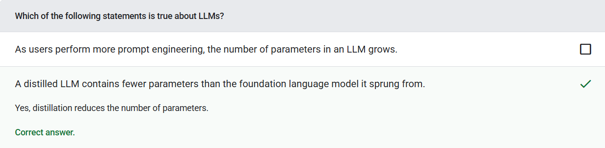
Backpropagation - The algorithm that implements gradient descent in neural networks.
Distillation - The process of reducing the size of one model (known as the teacher) into a smaller model (known as the student) that emulates the original model's predictions as faithfully as possible. Distillation is useful because the smaller model has two key benefits over the larger model (the teacher):
• Faster inference time
• Reduced memory and energy usage
Few-shot prompting - A prompt that contains more than one (a "few") example demonstrating how the large language model should respond.
Fine-tuning - A second, task-specific training pass performed on a pre-trained model to refine its parameters for a specific use case.
Offline inference - The process of a model generating a batch of predictions and then caching (saving) those predictions. Apps can then access the inferred prediction from the cache rather than rerunning the model.
One-shot prompting - A prompt that contains one example demonstrating how the large language model should respond.
Online inference - Generating predictions on demand.
Parameter-efficient tuning - A set of techniques to fine-tune a large pre-trained language model (PLM) more efficiently than full fine-tuning. Parameter-efficient tuning typically fine-tunes far fewer parameters than full fine-tuning, yet generally produces a large language model that performs as well (or almost as well) as a large language model built from full fine-tuning.
Prompt engineering - The art of creating prompts that elicit the desired responses from a large language model. Humans perform prompt engineering.
Zero-shot prompting - A prompt that does not provide an example of how you want the large language model to respond.
Test


